Documentation on File Record
First set Client workflow and warrant action mapping from Super Admin
To set Client workflow, Login as super admin then go to Client Work Flow Listing click on edit button. Set below workflow
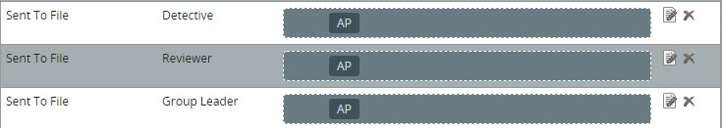
Also add File Record workflow option in Judge Approved – Detective
Now add below action mapping
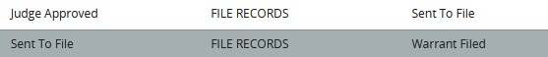

After Setting Client workflow and warrant action mapping
Login as a detective, Create and submit a warrant to a Judge.
After Judge approves the warrant, then the detective can send the file by clicking on File Records option from the action menu.
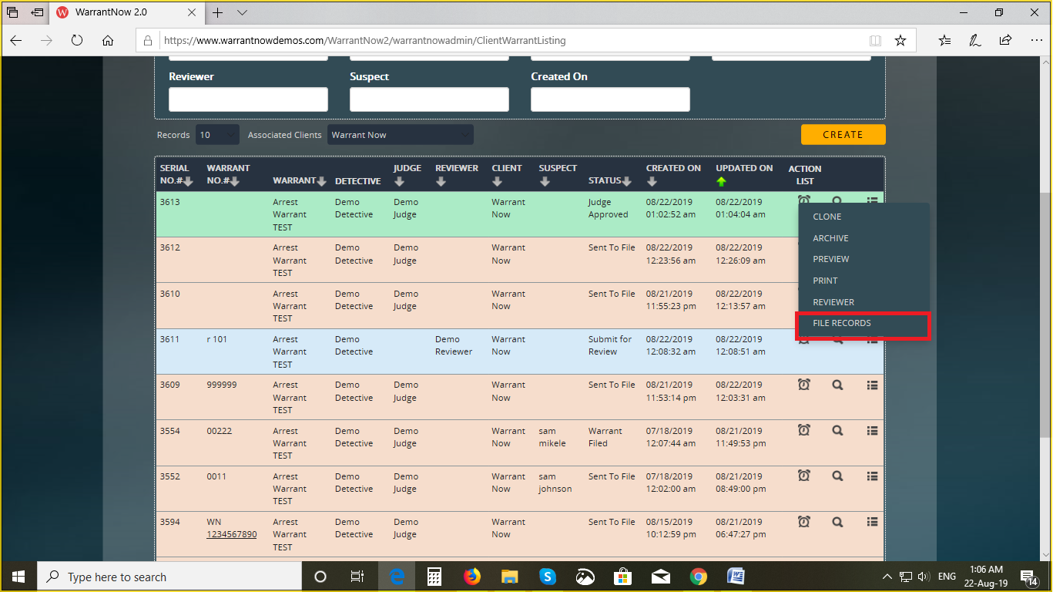
After clicking on the File Records option, a dialog box will be open
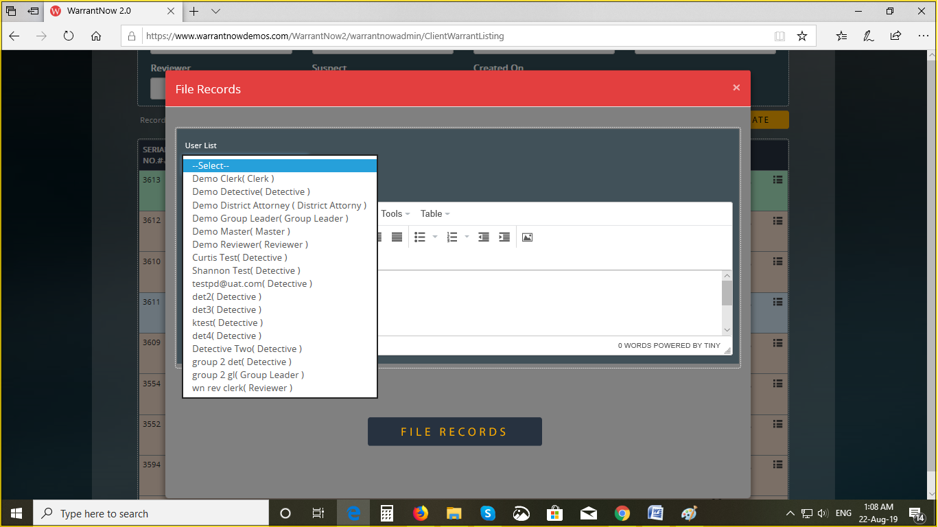
Select the user from the list and click on the File Record button.
Now login as a selected user and follow the below steps.
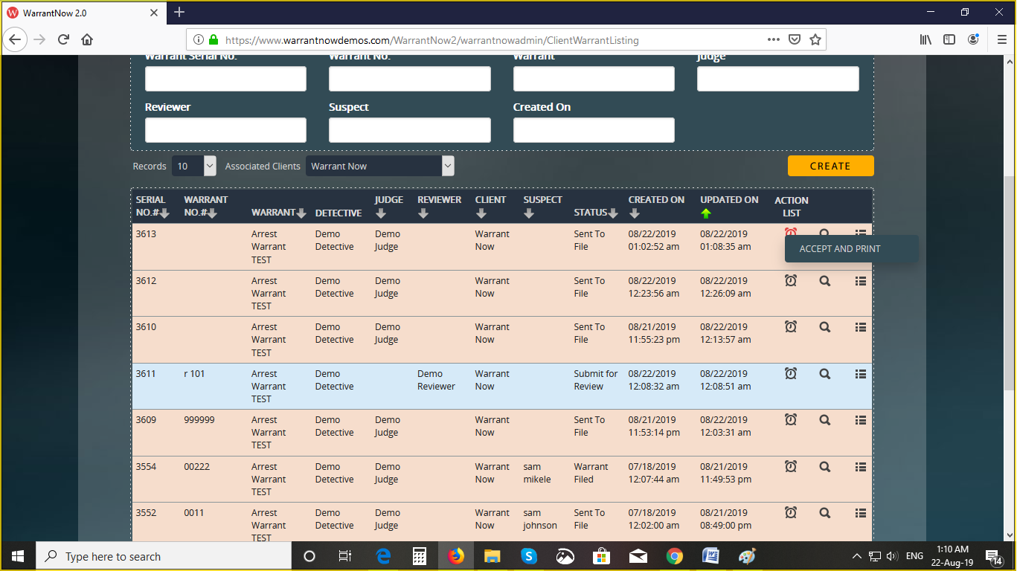
Clicking on the Accept and Print option from the action menu, the File Records dialog box will be opend.
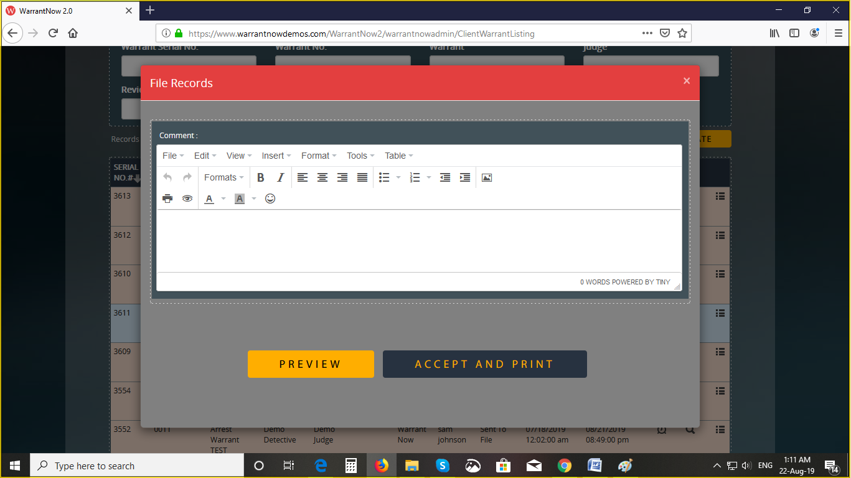
Here you can either Preview the file or Accept and print the file.

